T.W.T RS485
Controller_MODBUS-RTU Protocol Description
Version: V1.3
Data in this protocol includes: Hexadecimal numbers, Integers, BCD codes, and Floating-point numbers.
For the register addresses listed in the following table, the "Attribute" indicates the read/write permission:
• R: Read-only
• W: Write-only
• R/W: Readable and writable
400W Inverter_MODBUS-RTU Protocol Data Description
Attribute | Address (hex/word) | Register Length (word) | Data Type | Description | Note (Example)
(Acquisition Data Information)
R | 0 | 2 | UINT | Display panel firmware version number | ---
R | 1 | 2 | UINT | Power drive board firmware version number | ---
R/W | 2 | 2 | UINT | Frequency (Speed setting and feedback) | 500/10=50.0Hz
R/W | 3 | 2 | UINT | Start/Stop command and operating status feedback | 1: Forward Run2: Stop5: Reverse Run
R | 4 | 2 | --- | --- | Reserved
R | 5 | 2 | --- | --- | Reserved
R | 6 | 2 | --- | --- | Reserved
R | 7 | 2 | --- | --- | Reserved
R | 8 | 2 | UINT | DC bus voltage value (V) | 3100/10=310.0V
R | 9 | 2 | UINT | DC bus current value (A) | 132/100=1.32A
R | 10 | 2 | UINT | Heatsink temperature (°C) | 43=43°C
R | 11 | 2 | UINT | --- | Reserved
R | 12 | 2 | UINT | --- | Reserved
R | 13 | 2 | UINT | --- | Reserved
R | 14 | 2 | UINT | --- | Reserved
R | 15 | 2 | UINT | --- | Reserved
R | 16 | 1 | UINT | --- | Reserved
R | 17 | 1 | UINT | --- | Reserved

1. Data Format Description
1.1. Communication Mode
This instrument adopts the MODBUS RTU format.
The protocol uses a master-slave query/response model for data communication. The communication flow is shown in the figure below.
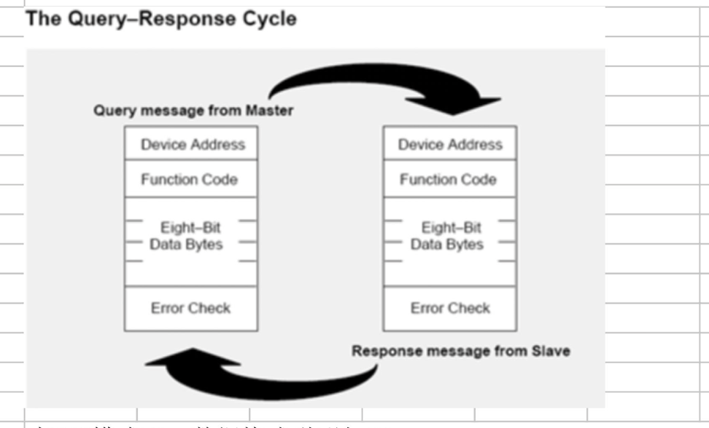
As for RTU format, the figure below
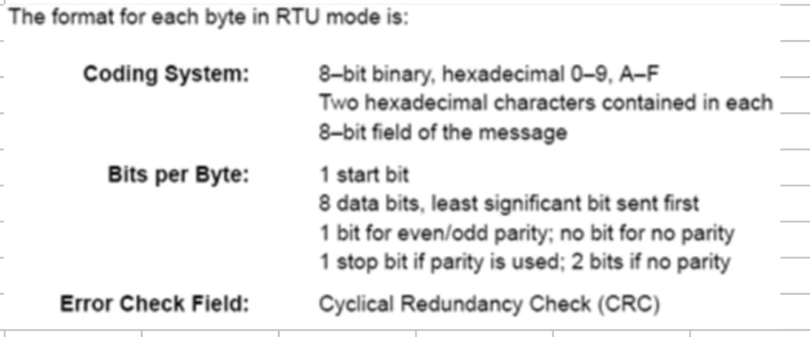

1.2 Data Format
Supported serial port data formats:
• 8N1: 1 start bit, 8 data bits, no parity, 1 stop bit
• 8N2: 1 start bit, 8 data bits, no parity, 2 stop bits
• 8E1: 1 start bit, 8 data bits, even parity, 1 stop bit
• 8O1: 1 start bit, 8 data bits, odd parity, 1 stop bit
Supported baud rates (5 options):
• 2400 (abbreviated as 24), 4800 (48), 9600 (96), 19200 (192), 38400 (384)
Similarly, if a new message begins earlier than 3.5 character times following a previous message, the receiving device will consider it a continuation of the previous message. This will trigger an error, as the CRC checksum will be invalid for the combined messages. A typical message frame is structured as follows:
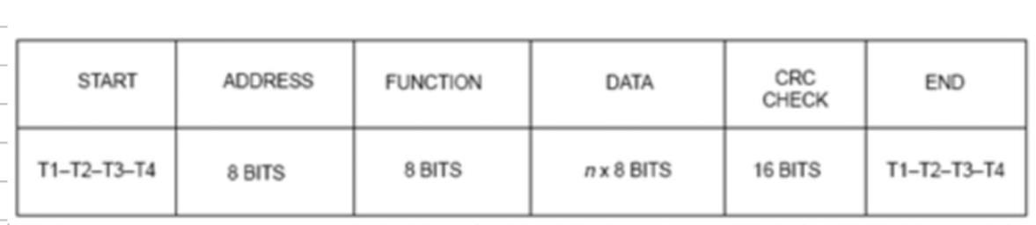
Where: T1, T2, T3, T4 represent the inter-frame time intervals. The transmission between two frames must exceed this interval time.
1.3 Device Address
(Note: The full content of this section is not visible in the provided image.)
The protocol defines instrument addresses as 01–249 (decimal). Address 0 is reserved for broadcast messages, which this protocol does not support. All other addresses are reserved for future use.
2. MODBUS RTU Command Format Description
2.1 Supported MODBUS Commands
Command Code (HEX) | Function | Notes
3 | Read single or multiple registers
6 | Write single register | This command is included in the "Command" set
2.2 Data Format
Data types supported in this protocol include:
• Hexadecimal numbers
• Integers
• BCD codes
• Floating-point numbers
For register addresses listed in subsequent tables:
• R: Read-only
• W: Write-only
• R/W: Readable and writable
MODBUS Response Frame0
Field | Size | Range/Value
Device Address | 1 BYTE | 01–249
Function Code | 1 BYTE | 0x03
Starting Address | 2 BYTE | 0x00–0xFFFF
Read Quantity | 2 BYTE | 0x01–0x7D
CRC Low Byte | 1 BYTE | Calculated checksum
CRC High Byte | 1 BYTE | Calculated checksum

Modbus Response Frame
Field | Size | Range/Value
Device Address | 1 BYTE | 01–249
Function Code | 1 BYTE | 0x03
Byte Count | 1 BYTE | N (number of data bytes)
Input Data | 2×N BYTE | Register values
CRC Low Byte | 1 BYTE | Calculated checksum
CRC High Byte | 1 BYTE | Calculated checksum

Example (Read Command)
Request |  |  | Response
Field Name | Data (HEX) |  | Field Name | Data (HEX)
Device Address | 1 |  | Device Address | 1
Function Code | 3 |  | Function Code | 3
Starting Address High | 0 |  | Byte Count | 6
Starting Address Low | 6B (108) |  | Register 1 High | 2
Read Quantity High | 0 |  | Register 1 Low | 2B (109)
Read Quantity Low | 3 |  | Register 2 High | 0
 |  |  | Register 2 Low | 0
 |  |  | Register 3 High | 0
 |  |  | Register 3 Low | 64 (100)
CRC Checksum | (Check code) |  | CRC Checksum | (Check code)

Command 06 (HEX): Write Single Register Command

MODBUS Request Frame
Field | Size | Range/Value
Device Address | 1 BYTE | 01–249
Function Code | 1 BYTE | 0x06
Register Address | 2 BYTE | 0x00–0xFFFF
Register Data | 2 BYTE | 0x00–0xFFFF
CRC Low Byte | 1 BYTE | Calculated checksum
CRC High Byte | 1 BYTE | Calculated checksum

MODBUS Response Frame (Echoes the request if successful)
Field | Size | Range/Value
Device Address | 1 BYTE | 01–249
Function Code | 1 BYTE | 0x06
Register Address | 2 BYTE | 0x00–0xFFFF
Register Data | 2 BYTE | 0x00–0xFFFF
CRC Low Byte | 1 BYTE | Calculated checksum
CRC High Byte | 1 BYTE | Calculated checksum

Example
Request |  |  | Response
Field Name | Data (hex) |  | Field Name | Data (hex)
Slave Address | 1 |  | Slave Address | 1
Function Code | 6 |  | Function Code | 6
Register Address (High) | 0 |  | Starting Address (High Byte) | 0
Register Address (Low) | 6B |  | Starting Address (Low Byte) | 6B
Register Value (High) | 0 |  | Register Value (High) | 0
Register Value (Low) | 0F |  | Register Value (Low) | 0F
CRC Checksum | Check code |  | CRC Checksum | Check code

